Advanced Analytic Rigour
Seminar 3 – Practice Exercise
The Hunt Laboratory for Intelligence Research
October 2020
CONTACT

Ashley Barnett
Research Associate
Email: barnett.a@unimelb.edu.au

Tamar Primoratz
Research Associate
Email: tpri@unimelb.edu.au

Tips for using the argument mapping software Rationale
- It doesn’t have an autosave – you will need to manually save your work.

- In the building panel select “Advance Reasoning” mode.
(You can make this the default by clicking the cog icon)

- To share your work you will need to return to the “My Maps” page. It may be open in another tab, but if not, you can access it from the workspace by clicking on the yellow folder icon in the top right menu.
From the “My Maps” page select the map you want to share.
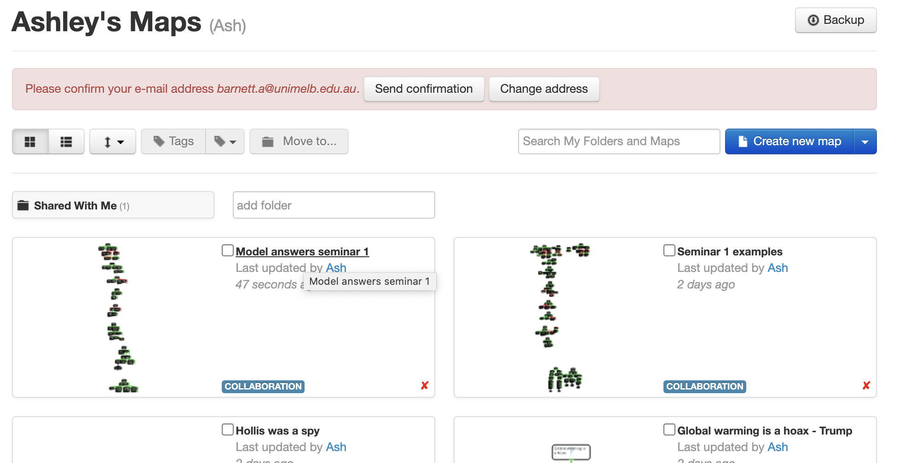
Click the arrow near the “make public” option and select “unlisted”. Email Barnett.a@unimelb.edu.au the URL and I will send you back a copy with comments.

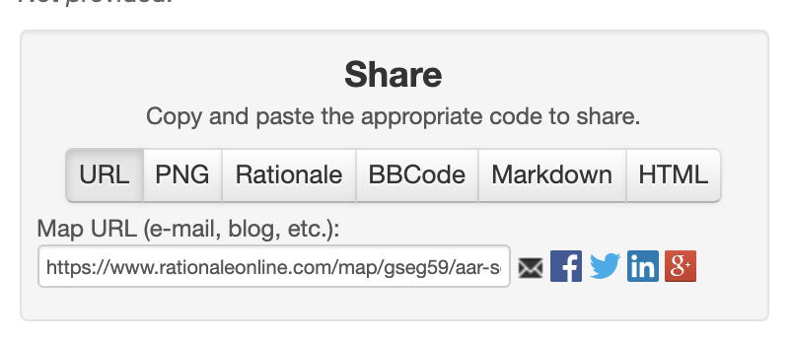

Seminar 2: Practice Exercises

1: Underlying logic of an argument

Demonstration
Bob is planning a terrorist attack. We have two reasons to believe this:
1) He has purchased materials to build a bomb
2) He has acquired a large amount of fertiliser.
Furthermore, Bob doesn’t work on a farm or do any agricultural work

Exercise 1
Australian Strategic Policy Institute executive director Peter Jennings told The Australian it was “very clear” that China was behind the cyber attack on Australia […]
“I think you’ve got to sort of go through a check list of factors, which is not just the capability issues that Morrison talks about but also the interest and intent,” Mr Jennings said in the wake of the PM’s press conference announcing the attack.
“The Russians could do it. The North Koreans could do it, but neither of them have an interest on the scale of this. They have no interest in state and territory government or universities,”
“So that leads me to conclude that the only country that has got the interest to go as broad and as deep as this and the only country with the sophistication and the size of the intelligence establishment to do it, is China. That’s very clear.
“I think you can sort of attribute 95 per cent of confidence to it being China.”
- Peter Jennings, head of the Australian Strategic Policy Institute.

Exercise 2
"Nothing of the sort. I knew you came from Afghanistan. From long habit the train of thoughts ran so swiftly through my mind, that I arrived at the conclusion without being conscious of intermediate steps. There were such steps, however. The train of reasoning ran, “Here is a gentleman of a medical type, but with the air of a military man. Clearly an army doctor then. He has just come from the tropics, for his face is dark, and that is not the natural tint of his skin, for his wrists are fair. He has undergone hardship and sickness, as his haggard face says clearly. His left arm has been injured. He holds it in a stiff and unnatural manner. Where in the tropics could an English army doctor have seen much hardship and got his arm wounded? Clearly in Afghanistan.” The whole train of thought did not occupy a second. I then remarked that you came from Afghanistan, and you were astonished."
- A Study In Scarlet, Arthur Conan Doyle, 1887.

Exercise 3
America’s dependence on China is a systemic risk. The outbreak of the corona virus provides proof of this. America is dependent on China for many vital goods. Yanzhong Huang, a global-health expert at the Council on Foreign Relations, noted that China is the largest exporter of medical devices to the United States, and that about 80 percent of the active pharmaceutical ingredients in American drugs come from China and India. “Chinese pharmaceutical firms have captured 97 percent of the US market for antibiotics and more than 90 percent of the market for vitamin C,” he wrote. “In 2018, 95 percent of ibuprofen, 91 percent of hydrocortisone, 70 percent of acetaminophen, and 40–45 percent of [the blood thinner] heparin imported to the United States came from China.”
The corona virus outbreak has demonstrated how vulnerable China is, and this will not be a one-off event, because authoritarian governments are especially likely to hinder international responses to global threats. “Anywhere you see a closed, centralized, nontransparent regime, you see the inability to flex quickly as crisis emerges,” explained Goldberg, now a senior adviser at the Foundation for Defense of Democracies. Democracies, too, “can fail,” he allowed, but they also “can respond to failure and correct [themselves] quickly.”
- Based on material taken from https://www.theatlantic.com/politics/archive/2020/03/coronavirus-crisis-china-trump-trade-economy/607747/

Exercise 5
Tindal Air Base Expansion Shows the Way to a More Secure Region
The government’s decision to significantly expand the Royal Australian Air Force’s key northern base near Katherine, around 300 kilometres southeast of Darwin, is a giant strategic step forward and will deliver a firmer deterrent posture and a closer alliance with the U.S. I’m very positive about this military strengthening, not least because a decade ago I led the Defence Department effort to expand cooperation with the U.S. in northern Australia. There were three reasons for establishing a U.S. Marine Corps presence in the north and planning for increased cooperation between our air forces and navies. First, it added a new dimension of closer cooperation with the U.S., deepening American engagement in, and commitment to, Australian security. This is a hugely valuable deterrent asset for Australia, one that complicates the planning of any potential adversary. Second, this cooperation will modernise the alliance and make it better suited to handle emerging threats. The northern focus will be on having the ability to rapidly disperse and deploy forces over large distances, extend the range of combat hitting power and bring our military forces into more effective high-technology cooperation. Third, enhanced northern cooperation is a strong signal of American and Australian interest in the security of Southeast Asia.
Geography doesn’t change. Southeast Asia was the strategic fulcrum around which the Pacific War was fought, and it is the region most sharply in Beijing’s sights as the Chinese Communist Party seeks to weaken America’s security leadership in the Asia–Pacific. A much sharper strategic competition for influence is building in Asia between the U.S. and China. Australia can’t opt out of this reality. Washington and its key allies in the Indo-Pacific—Japan and Australia—need to give the wider region some confidence that collectively we can push back against Beijing’s bullying [...] In Australia, a variegated collection of China boosters, U.S. alliance haters and people determined to see in our modest defence companies a ‘mini-me’ military–industrial complex, will complain about the government’s initiative and, indeed, about ASPI’s gall in talking frankly about the strategic risks posed by an assertive, authoritarian China. Can Beijing’s response and its domestic echoes be completely unconnected? China’s palpable decision to turn the diplomatic dial to ‘loud and angry’ has been noted around the world. It seems that any national expression of independence not completely aligned with ‘Xi Jinping thought’ will be aggressively refuted. Any attempt to enhance Australian and American military cooperation—which has been at the core of our defence policy since before the communist take-over in China—will be treated as an affront by Beijing.
None of that should matter to Scott Morrison. A more private Chinese leadership reaction will be to regard the Tindal announcement as a logical strategic response to China’s influence-building in Southeast Asia. Beijing’s strategic planners are opportunistic realists. They understand how to make tough judgements based on national interest and they will see the Tindal announcement in that light. China views Australia’s defence alliance with the United States with a mix of envy and puzzlement. Beijing is envious because the alliance gives Australia access to a trove of technology and information that China could never source through willing partnerships. Its puzzlement is about how countries can cooperate so effectively based on trust, strategic interest and shared values. China does not have these types of relationships.

2: Reasoning Stratagems
Exercise 1
The QuackCon conspiracy theory group in Australia shares a similar ideology to the QuackCon group in the UK, and has the same goals and resources. Both here and in the UK, QuackCon members believe the world is run by a cabal of evil aliens in human form that need to be overthrown. The group in the UK has carried out terrorist attacks. Therefore, it is probable that the Australian wing is planning or will plan a terrorist attack here.

Exercise 2
Physical books are technologically obsolete, and the book industry is heading down the path that the music industry took, where digital downloads decimated CD sales and put record stores out of business. Between 2009 and 2011, e-book sales rose at triple-digit annual rates.
- Adapted from James Surowiecki, “E-Book Vs. P-Book”, New Yorker July 2013

Exercise 3
We predict that within his current term, Japan's prime minister, Shinzo Abe, will attempt to revise Japan's 1947 post-war constitution by removing article 9 that outlawed war except in self-defence. It has been a lifelong goal of his and he now has the legislative power to attempt a change. He is merely waiting for the moment when he is likely to succeed. Soon he will have overwhelming public support, because before too long the majority of the Japanese public will believe that Japan needs to increase its military in response to China's rising military power.

Exercise 4
In my view, …taking into account all relevant (and available) information about Monis, what would have emerged was an individual whose concerning behaviour was escalating, including in the “security” arena, such as to justify the commencement of a formal investigation by ASIO. What that information comprises is detailed in the closed version of this chapter. In essence, there had been a malignant shift in Monis’ presentation—reflected in his apparent increased violence (exhibited by his involvement in his ex-wife’s murder, and his posting of graphic images from conflict zones), coupled with a burgeoning interest in IS pointing toward radicalisation.
http://www.lindtinquest.justice.nsw.gov.au/Documents/findings-and-recommendations.pdf page 402.

Exercise 5

Palestinian Islamic Jihad
This statement is based on publicly available information about Palestinian Islamic Jihad. To the Australian Government's knowledge, this information is accurate, reliable and has been corroborated by classified information.
Basis for listing a terrorist organisation:
Division 102 of the Criminal Code provides that for an organisation to be listed as a terrorist organisation, the Minister for Home Affairs must be satisfied on reasonable grounds that the organisation:
- is directly or indirectly engaged in, preparing, planning, or assisting in or fostering the doing of a terrorist act; or
- advocates the doing of a terrorist act.
For the purposes of listing a terrorist organisation under the Criminal Code, the doing of a terrorist act includes the doing of a specific terrorist act, the doing of more than one terrorist act and the doing of a terrorist act, even if a terrorist act does not occur.
Advocating the doing of terrorist acts
PIJ encourages Palestinians to attack Israel and to celebrate violent resistance against Israel; and advocates the use of terrorist tactics in its public messaging. PIJ maintains an Arabic website, which is used to celebrate Jihadist operations, memorialise martyrs, and promote anti-Israeli propaganda.
- On 9 January 2018, an Israeli Rabbi was shot and injured in a drive by shooting west of Nablus. PIJ praised the attack stating that the incident illustrated the continuity and vitality of the resistance against Israel, and that the Palestinian people will not abandon their cause.
- On 26 September 2017, an Israeli border police officer, and two security guards were killed and one was injured when an individual opened fire on the group near Jerusalem. Following the attack, PIJ released a statement praising the attack stating the incident was a rebuke to those who support Israel.

Exercise 6
What does the Chinese Communist Party want from Australia?
Duncan Lewis, who was not only the previous head of the Australian Security Intelligence Organisation (ASIO) but also commander of Australia’s Special Forces, secretary of the Defence Department and Australia’s inaugural national security adviser, is especially well qualified to answer. “They are trying to place themselves in a position of advantage,” he told me in an interview shortly after retiring in September.
In a post-retirement interview, former ASIO boss Duncan Lewis said while it was not only China that preoccupied the Australian authorities, it was "overwhelmingly" China.
“Espionage and foreign interference is insidious. Its effects might not present for decades and by that time, it’s too late. You wake up one day and find decisions made in our country that are not in the interests of our country. Not only in politics but also in the community or in business. It takes over, basically, pulling the strings from offshore.” Note that, although Lewis was a longtime soldier, traditional military invasion does not feature in his answer. This is the modern way of intelligent statecraft, conquest and control without war.
- https://www.smh.com.au/national/peter-hartcher-on-china-s-infiltration-of-australia-20191118-p53bly.html

Exercise 7
In COVID’s shadow, global terrorism has gone quiet but we should still be wary. Having lost its physical caliphate, Islamic State appears to have lost its capacity, if not its willingness, to launch attacks around the world well beyond conflict zones. But we have seen this happen before. The September 11 attacks in 2001 were followed by a wave of attacks around the world. Since 2005, except for the Charlie Hebdo shootings in Paris in January 2015, al-Qaeda has been prevented from launching any major attacks in western capitals. Then in 2013, Islamic State emerged and brought a new wave of attacks. While it’s tempting to conclude that the ending of the current wave of international terrorist attacks by IS is due largely to the ending of the physical caliphate in Syria and Iraq, and a concomitant collapse of capacity, the reality is more complex. The parallels with the epidemiology of viruses are striking. Terrorism works as a phenomenon that depends on social contact and exchange and expands rapidly in an opportunistic fashion when defences are lowered. Reasoning by analogy is imperfect, but it can be a powerful way of prompting reflection. The importance of this cannot be underestimated as intelligence failures in counterterrorism, like poor political responses to pandemics, are in large part failures of imagination. It is true we have successfully dealt with two waves of global terrorist attacks over the past two decades, but we have not dealt successfully the underlying source of infections. In fact, we have contributed, through military campaigns, to weakening the body politic of host countries in which groups like al-Qaeda, IS and other violent extremist groups have a parasitic presence. We now need to face the inconvenient truth that toxic identity politics and the tribal dynamics of hate have infected western democracies and that eliminating the viral spread of hateful extremism is extremely hard.
https://theconversation.com/in-covids-shadow-global-terrorism-goes-quiet-but-we-have-seen-this-before-and-should-be-wary-144286

Exercise 8
It was early October when I picked up my phone to learn that a Chinese spy had decided to defect. Over the next few weeks, I played a small role working with 60 Minutes, The Sydney Morning Herald and The Age to help verify and analyse Wang Liqiang’s claims – and eventually meet Wang himself.
My jaw dropped as I read Wang’s 12-page Chinese-language confession and plea for help. The statement touched on some of the most disturbing aspects of the Chinese Communist Party’s political interference: efforts to manipulate Taiwan’s elections, infiltration of student organisations in Hong Kong, and even the kidnapping of political dissidents. Names of organisations and key figures in Chinese military intelligence, including some that I was studying at the time, jumped out at me.
It was almost too good to be true. How could a 26 year old with no military or government background find himself close to the centre of the People’s Liberation Army’s intelligence network in Hong Kong?
Defections are never simple – neither in execution and motivation. Yu Qiangsheng, a senior intelligence officer who defected from Beijing to Washington in the 1980s, exposing two moles in the process, may have done so in part out of frustration with his personal life and sense of thrill. With a case like Wang’s that crosses between several regions, it’s impossible to verify every claim. Past defectors who were nonetheless genuine have been accused of spicing up their stories in misguided attempts to strengthen their asylum claims
Wang does not fit into black and white categories. He does not appear to hold any rank within Chinese military intelligence. His formal education was in fine arts and he originally joined what he claims was a front company thinking he would be involved in cultural activities. Based on his own account of events, he was effectively running errands for an intelligence officer. Spy, agent, intelligence officer – none of these terms are an exact match for Wang’s role.
But as I dug further into his statement, it was possible to find support for some claims. Wang claims that Xiang Xin, a wealthy businessman he worked for, is at the centre of a military intelligence network and was sent to Hong Kong by a defence technology agency called COSTIND ahead of the 1997 handover. COSTIND is a now-defunct defence agency that was tasked with modernising China’s military technology. It sought to strengthen China’s defence innovation system, and also played a central role in the pilfering and collection of foreign defence technology.
Xiang’s companies have had close business dealings with Chinese state-owned defence companies such as Norinco Group. The first companies he directed in Hong Kong shared similar names with COSTIND’s arms export front, New Era Corporation. Several past executives of Xiang’s companies had backgrounds in defence companies subordinate to COSTIND. At least one appears to have worked for a known COSTIND front company in Hong Kong at the same time. Xiang is graduate of one of COSTIND’s seven universities and established its alumni association in Hong Kong. His wife, also alleged by Wang to be a spy, previously worked in COSTIND’s Intelligence Research Institute. In other words, Xiang was associated with members of military front companies. He had personal connections to COSTIND at the same time as the People’s Liberation Army was aggressively expanding its business presence in Hong Kong.
Wang’s statement also names dozens of alleged assets who occupy prominent positions in Taiwanese and Hong Kong society. Sooner or later, intelligence agencies in Australia, Taiwan, Britain and the United States will be able to confirm or refute these specific claims.
The Chinese government has quickly responded with a notice from the Shanghai Public Security Bureau claiming that it has been investigating him for fraud. Backed up by an online court record, authorities claim that Wang was also convicted of fraud in 2016. We shouldn’t dismiss these allegations off hand, but there is evidence that could cast serious doubt on them.
Wang claims he obtained a police check from the Chinese government for his Australian visa application. Issued in February 2019 by the same county that supposedly convicted him of fraud, it found he had no criminal record.
Stamps in Wang’s passport contradict the bureau's suggestion that he was on bail and restricted to a rural county for most of 2016, pending a court decision. The Public Security Bureau claims that Wang left China in April using a fake Chinese passport. Wang has said three fake ID documents were created for his mission to Taiwan but he did not receive them before he left the country. He had them posted to a friend who sent scans of them. It is also unclear how he could have left the country using a fake biometric passport.
Search engine queries for his supposed conviction return no results that predate reports of his defection. The Chinese government’s court records database contains the ruling, but a large privately owned database of Chinese legal cases curiously does not.
Arguably, each piece of evidence against the Chinese government’s claims adds to a picture that it is trying to silence him because he is speaking the truth. The detail in some of Wang’s claims means that government investigations should uncover the facts eventually. But we don’t know the full story and we probably never will.
- Alex Joske is an analyst at the Australian Strategic Policy Institute’s International Cyber Policy Centre. https://www.theage.com.au/world/asia/defections-are-messy-and-we-may-never-know-the-full-story-20191123-p53dg6.html

Exercise 9
Possible Smuggling of Drambian Wildlife Products
We have information from two independent sources that prohibited wildlife or wildlife products are concealed in a shipment of antiques arriving in Homeport from Drambia in the last week of August (Wildlife Protection Agency. HUMINT report- Drambia Imports, 2019).
The two sources are members of rival criminal syndicates, the Archeros and the Burritos. Both syndicates have a history of involvement in gun smuggling, drug trafficking and manufacture, and extortion and other criminal activities. Historically they have fought over the same turf.
While the reliability of each source is questionable, we nonetheless deem the information highly credible, for the following reasons:
The information is so specific and detailed that the probability of its being independently concocted by each informant, or of each informant being mistaken in the same way, is negligible.
While both accounts cover most of the same details, each one describes different instances of smuggling and refers to different witnesses and actors. So, if the accounts are reliable, it appears that the sources have gained their information independently.
It’s extremely unlikely that members of these rival syndicates would collude in order to deliberately give us false information, as it is difficult to imagine what they might gain from doing so. If they were merging, or otherwise cooperating with each other more broadly, they might jointly feed us disinformation in order to divert our attention from their actual activities; but we have no information suggesting such a merger or new-found cooperation, and it is very unlikely given the longstanding rivalry between the two syndicates.
Hypothetically, the Archeros and Burritos might cooperate if they were forced to do so for their own survival: if a third syndicate posed a sufficient threat to both gangs, they might cooperate in order to remove the third player from the field. But neither syndicate has any history of involvement in smuggling wildlife or wildlife products. It’s unlikely that both syndicates have suddenly developed an interest in wildlife smuggling. More likely, the hypothetical third rival is involved both in wildlife smuggling and in activities that threaten the Archeros’ and Burritos’ own niche. We know of no such player. To our knowledge, the Archeros and Burritos are by far the biggest players in the field, so would be more likely to inform on each other than on a third party. Even if such a third player existed unbeknownst to us, it would be in the interest of both syndicates to give us true information in order to damage that player, and there would be no need for them to collude in order to do so (Homeport Police Department. Gangland Smuggling Investigation, 2019).
All of this points to the sources being independent and the information true, so the simplest explanation is also the most likely: that our informants in the Archeros and Burritos have independently come across the same information about this shipment and they leaked it to us for their own advantage, either to ingratiate themselves with us or to divert us from their own activities.
It is conceivable that a third syndicate is positioning itself in the market and spreading disinformation in order to divert everyone’s attention (ours as well as the Archeros’ and Burritos’) from its activities. They would be better served by leaking true information about their rivals, but if they have no true information then disinformation may have to do. This possibility is remote, but we cannot discount it, especially since we don’t know how it is that our sources independently could have come across the same detailed information.
We therefore assess with reasonable confidence (60-70%) that the information is true.

Exercise 10
WOMBEYAN CAVES, Australia — Deep in the burning forests south of Sydney this week, volunteer firefighters were clearing a track through the woods, hoping to hold back a nearby blaze, when one of them shouted over the crunching of bulldozers.
“Don’t take photos of any trees coming down,” he said. “The greenies will get a hold of it, and it’ll all be over.”
The idea that “greenies” or environmentalists would oppose measures to prevent fires from ravaging homes and lives is simply false. But the comment reflects a narrative that’s been promoted for months by conservative Australian media outlets, especially the influential newspapers and television stations owned by Rupert Murdoch.
And it’s far from the only Murdoch-fueled claim making the rounds. His standard-bearing national newspaper, The Australian, has also repeatedly argued that this year’s fires are no worse than those of the past — not true, scientists say, noting that 12 million acres have burned so far, with 2019 alone scorching more of New South Wales than the previous 15 years combined.
And on Wednesday, Mr. Murdoch’s News Corp, the largest media company in Australia, was found to be part of another wave of misinformation. An independent study found online bots and trolls exaggerating the role of arson in the fires, at the same time that an article in The Australian making similar assertions became the most popular offering on the newspaper’s website.
It’s all part of what critics see as a relentless effort led by the powerful media outlet to do what it has also done in the United States and Britain — shift blame to the left, protect conservative leaders and divert attention from climate change.
“It’s really reckless and extremely harmful,” said Joëlle Gergis, an award-winning climate scientist at the Australian National University. “It’s insidious because it grows. Once you plant those seeds of doubt, it stops an important conversation from taking place.”
News Corp denied playing such a role. “Our coverage has recognized Australia is having a conversation about climate change and how to respond to it,” the company said in an email. “The role of arsonists and policies that may have contributed to the spread of fire are, however, legitimate stories to report in the public interest.”
https://www.nytimes.com/2020/01/08/world/australia/fires-murdoch-disinformation.html

THE HUNT LABORATORY FOR INTELLIGENCE RESEARCH
CONTACT

Ashley Barnett Tamar Primoratz
Research Associate Research Associate
Email: barnett.a@unimelb.edu.au Email: tpri@unimelb.edu.au

