Advanced Analytic Rigour
Seminar 1 – Practice Exercise
The Hunt Laboratory for Intelligence Research
October 2020
CONTACT

Ashley Barnett
Research Associate
Email: barnett.a@unimelb.edu.au

Tamar Primoratz
Research Associate
Email: tpri@unimelb.edu.au

Seminar 1: Practice Exercises

1: The parts of argument (Zoom polls)

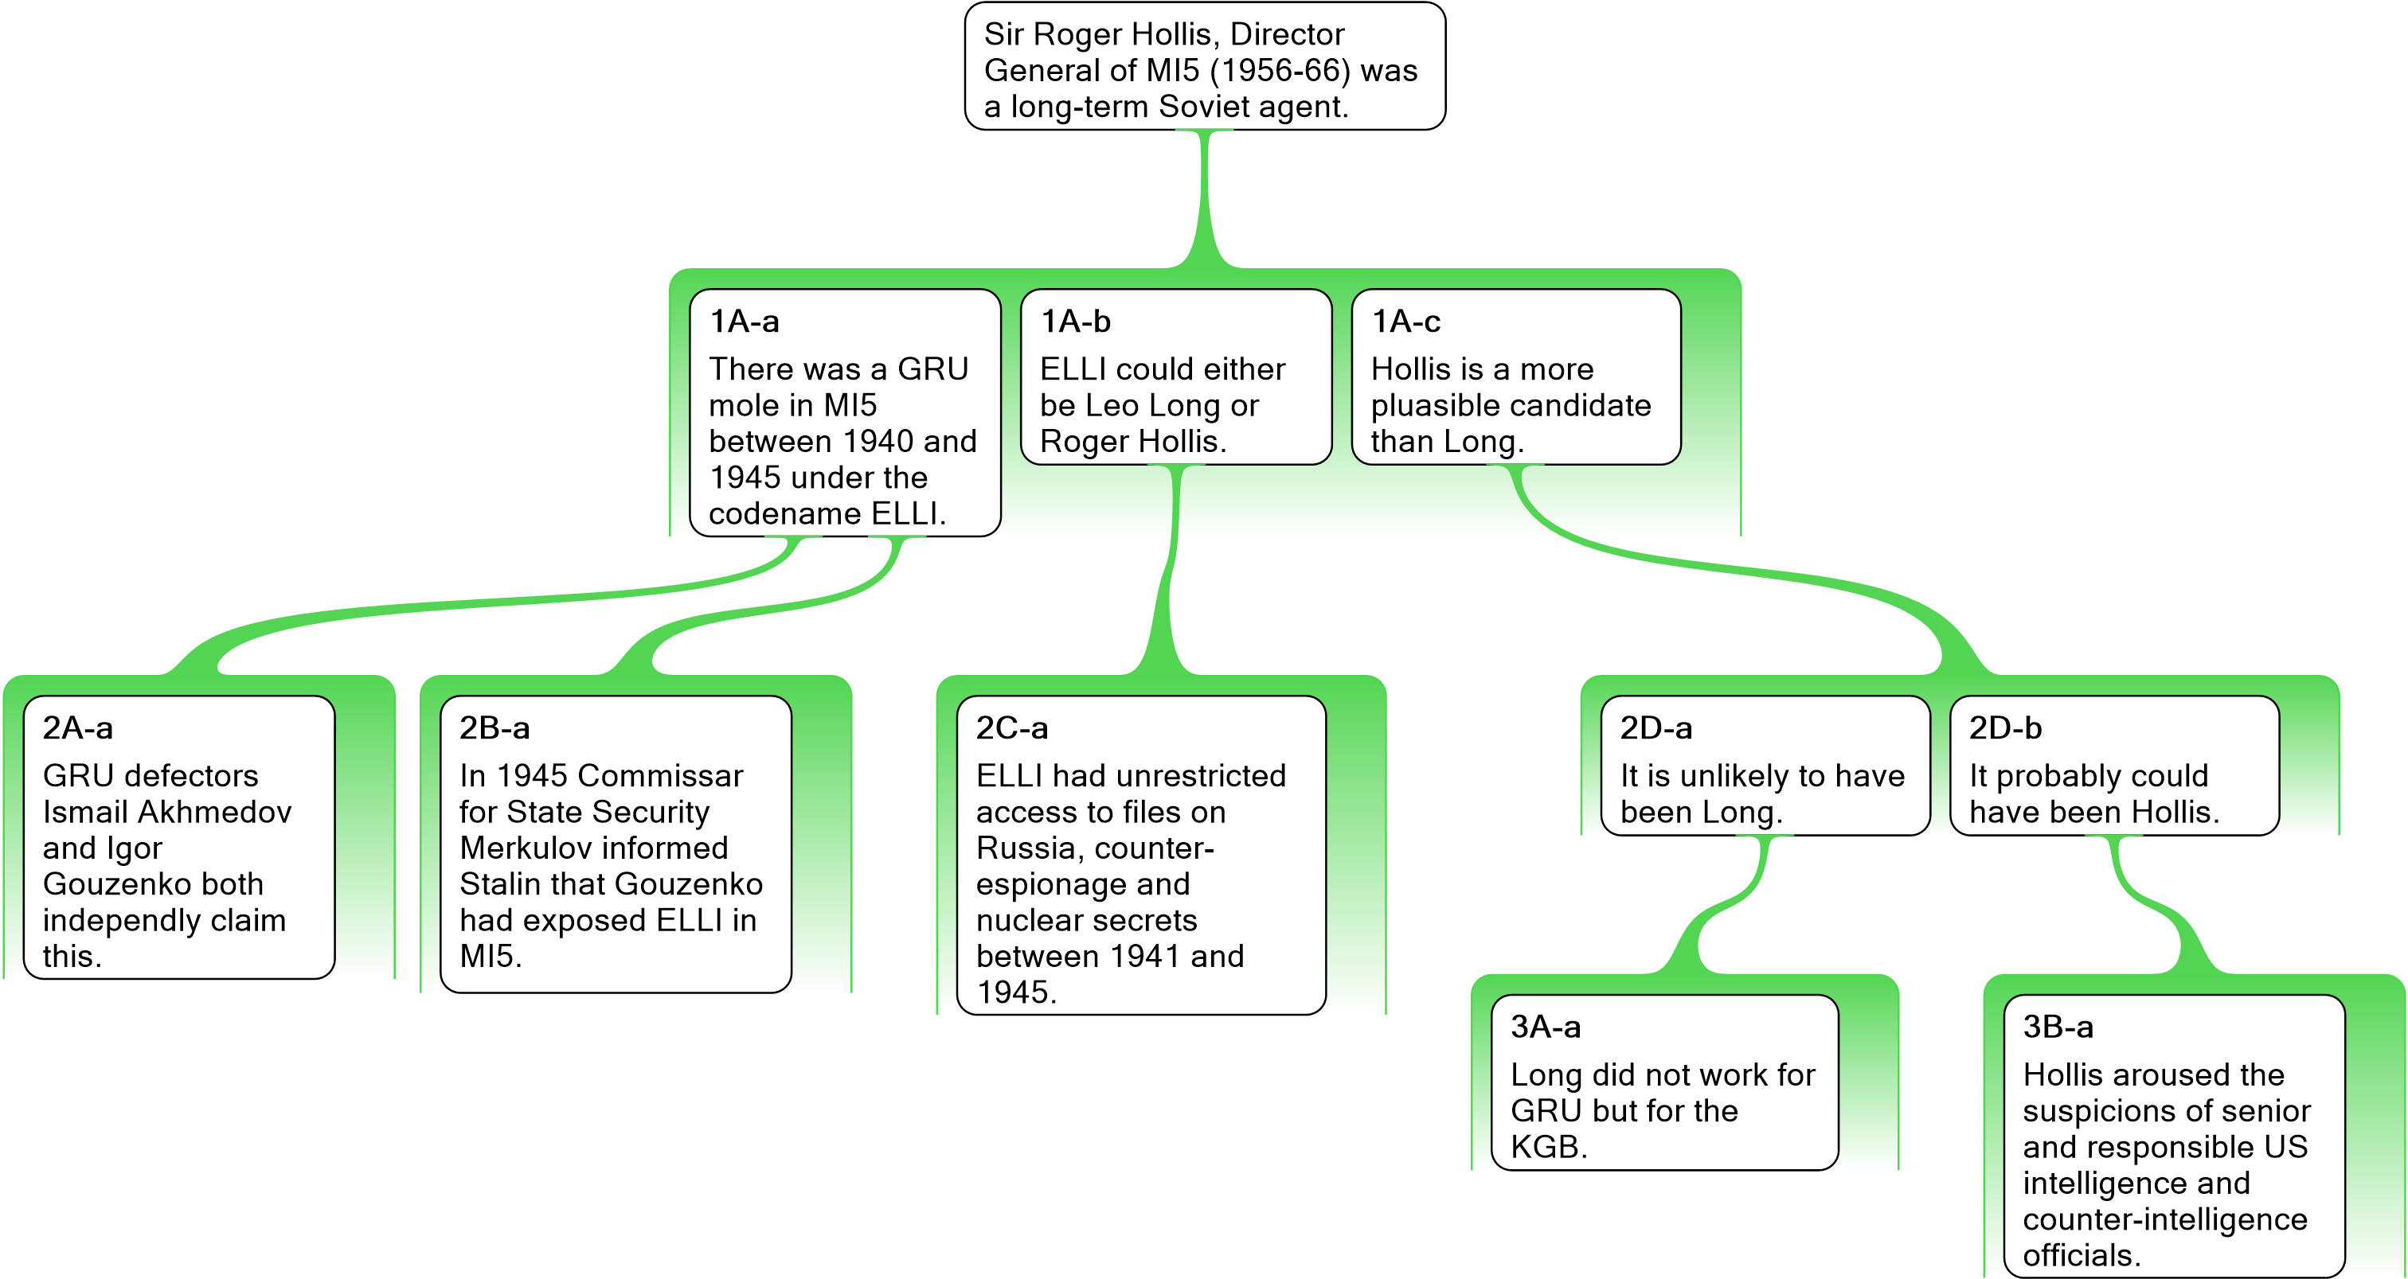

2: Argument Mapping

Demonstration
Jack: FDR wanted America to enter the war. It is well documented that he knew it was essential for America to join the war effort to prevent the spread of totalitarianism. Furthermore, FDR knew that the Japanese were going to attack Pearl Harbour and he just let it happen. He wouldn't have knowingly let the Pearl Harbour attack happen unless he wanted a justification to enter the war.
Jane: But, no one in US Navy intelligence suspected a surprise attack on Pearl Harbour.
Jack: He would have known that it was a consequence of his economic efforts to hinder Japan’s war in China.
Jane: Sounds like a conspiracy theory to me. Pearl Harbour was so costly to the US Navy no US president would have let it happen. If FDR wanted war with Japan he would have found some other justification.

Practice Exercises
Exercise 1
Stacy Burke is not the murderer because Burke’s fingerprints were not on the murder weapon. It is very likely that the murderer’s fingerprints would be on the murder weapon.
Furthermore, Burke was in London an hour before the murder took place. The murderer couldn’t have been in London an hour before the murder place. Burke was in London at 8:30 pm. The murder was at 9:30.

Exercise 2
Jane: The death penalty is unethical. The death penalty results in innocent people being wrongly executed. The wrongful execution of people is unethical.
Tom: But some crimes are so horrific that proportionate retribution can only be achieved via the death penalty. Achieving proportionate retribution is ethical.

Exercise 3
Radioactive elements disintegrate and eventually turn into lead. So if matter has always existed there should be no radioactive elements left. There are however, many radioactive elements such as uranium left in the world, which shows that matter has not always existed.

Exercise 4
Many people think that helmets should be compulsory for cyclists. But since the compulsory helmet law was passed, the number of people who cycle has declined, and this wouldn’t have happened unless having to buy a helmet was a disincentive for cycling. Helmets should only be compulsory if having to buy them is not a disincentive for cycling.

3: Argument Analysis
Exercise 1
Either the butler committed the murder or the judge committed the murder. Since the butler was passionately in love with the victim, it was not he who committed the murder. Therefore, the judge committed the murder.
Exercise 2
Some people argue that hate speech should be banned because it incites violence. But banning hate speech makes it harder to criticize as it would drive it further underground.
Exercise 3
The NATO withdrawal from Afghanistan will be extremely difficult. For one thing, the NATO withdrawal from Afghanistan will require large convoys, as NATO has to withdraw a huge amount of equipment from areas that can only be accessed by road. Large convoys in Afghanistan will make easy targets for the Taliban. Additionally, NATO has, in theory, the option to withdraw by either Pakistan or Afghanistan’s northern neighbours. However, Pakistan is too unreliable, so it will probably be best to withdraw via one of Afghanistan’s northern neighbours. This will require negotiation with the autocrats who run these countries.

4: Evaluating Complex Arguments
Exercise 1
Now is the time for the international community to ban weaponised robots. If they are not banned, then they will provide a cheap weapon capable of massive destruction and will cause many civilian casualties. A ban will be effective, so long as it is done now. Similar bans have prevented the spread of weapons in the past. A recent example is the UN Protocol on Blinding Laser Weapons, which came into force in 1998. The International Committee of the Red Cross argued that the ban was an historic step for humanity, stating that: “It represents the first time since 1868, when the use of exploding bullets was banned, that a weapon of military interest has been banned before its use on the battlefield and before a stream of victims gave visible proof of its tragic effects.” However, the ban needs to be done before killer robots get into the hands of militaries who are reluctant to give up weapons once they are acquired.

5: Underlying logic

Demonstration
Bob is planning a terrorist attack. We have two reasons to believe this:
1) He has purchased materials to build a bomb
2) He has acquired a large amount of fertiliser.
Furthermore, Bob doesn’t work on a farm or do any agricultural work

Exercise 1
Australian Strategic Policy Institute executive director Peter Jennings told The Australian it was “very clear” that China was behind the cyber attack on Australia […]
“I think you’ve got to sort of go through a check list of factors, which is not just the capability issues that Morrison talks about but also the interest and intent,” Mr Jennings said in the wake of the PM’s press conference announcing the attack.
“The Russians could do it. The North Koreans could do it, but neither of them have an interest on the scale of this. They have no interest in state and territory government or universities,”
“So that leads me to conclude that the only country that has got the interest to go as broad and as deep as this and the only country with the sophistication and the size of the intelligence establishment to do it, is China. That’s very clear.
“I think you can sort of attribute 95 per cent of confidence to it being China.”
- Peter Jennings, head of the Australian Strategic Policy Institute.

6: Arguments in natural language

Demonstration
"Nothing of the sort. I knew you came from Afghanistan. From long habit the train of thoughts ran so swiftly through my mind, that I arrived at the conclusion without being conscious of intermediate steps. There were such steps, however. The train of reasoning ran, “Here is a gentleman of a medical type, but with the air of a military man. Clearly an army doctor then. He has just come from the tropics, for his face is dark, and that is not the natural tint of his skin, for his wrists are fair. He has undergone hardship and sickness, as his haggard face says clearly. His left arm has been injured. He holds it in a stiff and unnatural manner. Where in the tropics could an English army doctor have seen much hardship and got his arm wounded? Clearly in Afghanistan.” The whole train of thought did not occupy a second. I then remarked that you came from Afghanistan, and you were astonished."
- A Study In Scarlet, Arthur Conan Doyle, 1887.

Exercise 1
We assess that there is a 30-70% chance that Samantha Smith is spying for the Republic of Khitan, a foreign adversarial country. Smith is an Australian politician who accepts large donations from Khitan and yet tries to minimize knowledge of her financial connections. Furthermore, she publicly defends the actions of the Khitanian ruling party, communicates regularly and covertly with top officials, and traveled there seven times for holidays in the last 3 years.

Exercise 2
Generations of European-history students have been taught that a political assassination caused the First World War. Without some qualification, however, this teaching is bound to mislead, since the war would not have happened without the treaties and alliances that were already in effect and the military force that was already amassed. These were the deeper causes of the war, whereas the assassination was a cause only in a trivial sense. It was like the individual spark that happens to ignite a conflagration that was, in the prevailing conditions, inevitable.

Exercise 3
In COVID’s shadow, global terrorism has gone quiet but we should still be wary. Having lost its physical caliphate, Islamic State appears to have lost its capacity, if not its willingness, to launch attacks around the world well beyond conflict zones. But we have seen this happen before. The September 11 attacks in 2001 were followed by a wave of attacks around the world. Since 2005, except for the Charlie Hebdo shootings in Paris in January 2015, al-Qaeda has been prevented from launching any major attacks in western capitals. Then in 2013, Islamic State emerged and brought a new wave of attacks. While it’s tempting to conclude that the ending of the current wave of international terrorist attacks by IS is due largely to the ending of the physical caliphate in Syria and Iraq, and a concomitant collapse of capacity, the reality is more complex. The parallels with the epidemiology of viruses are striking. Terrorism works as a phenomenon that depends on social contact and exchange and expands rapidly in an opportunistic fashion when defences are lowered. Reasoning by analogy is imperfect, but it can be a powerful way of prompting reflection. The importance of this cannot be underestimated as intelligence failures in counterterrorism, like poor political responses to pandemics, are in large part failures of imagination. It is true we have successfully dealt with two waves of global terrorist attacks over the past two decades, but we have not dealt successfully the underlying source of infections. In fact, we have contributed, through military campaigns, to weakening the body politic of host countries in which groups like al-Qaeda, IS and other violent extremist groups have a parasitic presence. We now need to face the inconvenient truth that toxic identity politics and the tribal dynamics of hate have infected western democracies and that eliminating the viral spread of hateful extremism is extremely hard.

Exercise 4
Every 2 hours, 3 people are killed in drunk driving crashes. A Pulse nightclub tragedy, every day and a half. All year long. Every year.
Understand that your right to drink comes at a high price. When our founding fathers added the amendment saying you had the constitutional right to keep and bear booze, that was long before Jaegermeister and Fireball. Obviously its time we . . . what? Not in the Constitution?
My point is that the outrage that happens when a madman, a terrorist, does what terrorists and madmen do, those who do not use firearms act with complete moral indignation because no one needs this thing that they don't want, so NO ONE should be allowed to have it.
But when a drunk driver kills an innocent person, there is never, never, NEVER a like reaction, because those morally indignant about firearms feel differently about alcohol. It is something they partake in, so obviously they should have the right, and screw those puritanical, sanctimonious a-holes that tell them they can't have a drink.
I personally believe honest citizens bearing arms help protect those who don't chose to own guns, due to the deterrent effect in place when a bad guy knows the door he kicks in or the person he robs on the street might earn him a look down a gun barrel. I don't think there is any such argument that we are safer with alcohol than without.
Last thing . . . PLEASE tell me that if we outlawed booze it wouldn't matter because people got it during prohibition. I need a good laugh today. (https://www.facebook.com/markstrodegreaney/posts/10153811441808040)

Exercise 5
America’s dependence on China is a systemic risk. The outbreak of the corona virus provides proof of this. America is dependent on China for many vital goods. Yanzhong Huang, a global-health expert at the Council on Foreign Relations, noted that China is the largest exporter of medical devices to the United States, and that about 80 percent of the active pharmaceutical ingredients in American drugs come from China and India. “Chinese pharmaceutical firms have captured 97 percent of the US market for antibiotics and more than 90 percent of the market for vitamin C,” he wrote. “In 2018, 95 percent of ibuprofen, 91 percent of hydrocortisone, 70 percent of acetaminophen, and 40–45 percent of [the blood thinner] heparin imported to the United States came from China.”
The corona virus outbreak has demonstrated how vulnerable China is, and this will not be a one-off event, because authoritarian governments are especially likely to hinder international responses to global threats. “Anywhere you see a closed, centralized, nontransparent regime, you see the inability to flex quickly as crisis emerges,” explained Goldberg, now a senior adviser at the Foundation for Defense of Democracies. Democracies, too, “can fail,” he allowed, but they also “can respond to failure and correct [themselves] quickly.”
- Based on material taken from https://www.theatlantic.com/politics/archive/2020/03/coronavirus-crisis-china-trump-trade-economy/607747/

THE HUNT LABORATORY FOR INTELLIGENCE RESEARCH
CONTACT

Ashley Barnett Tamar Primoratz
Research Associate Research Associate
Email: barnett.a@unimelb.edu.au Email: tpri@unimelb.edu.au

